TechNode

🎓 Definition
# Source: ScreenShots Source: Provided by: [Persons Table -> ID Column: 1, Name_En Column: Motasem Essam] -> Tool: [Lightshot Program] -> From [Site: https://technode.com/] on [11/13/2025]
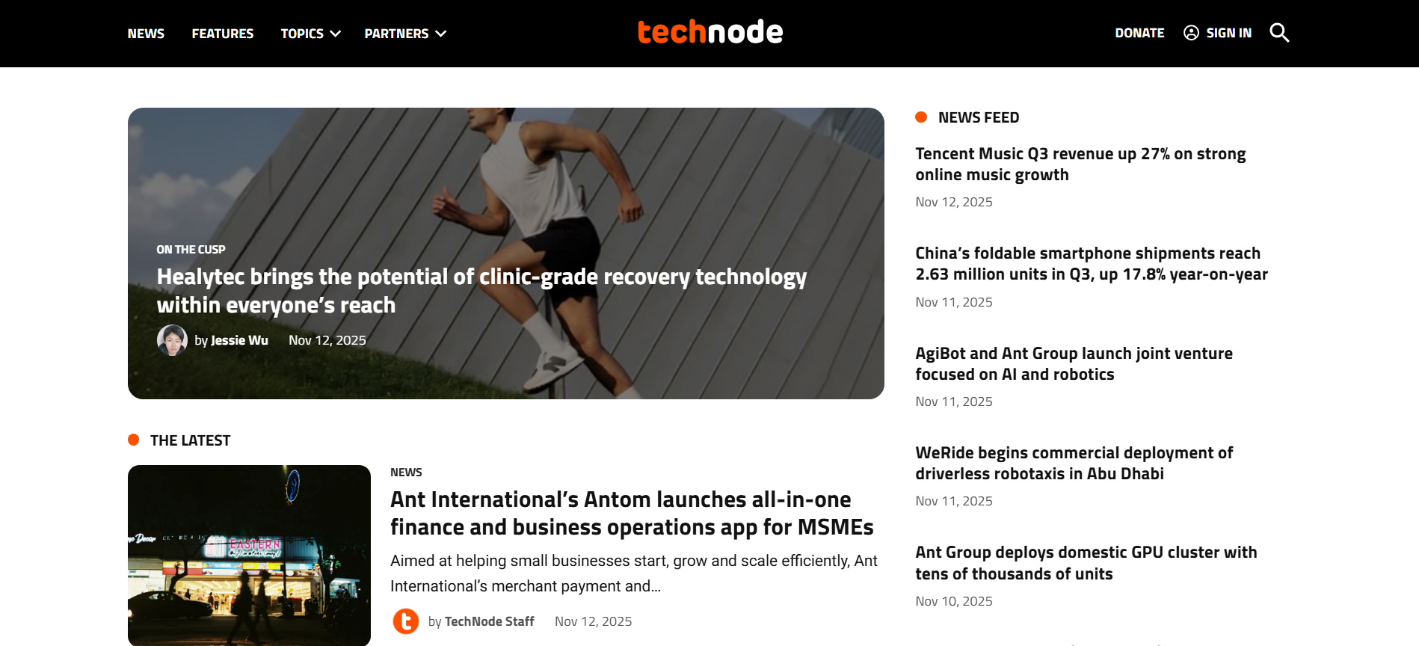
# Source: AI Source: Provided by: [Data Path: Persons Table -> ID Column: 1, Name_En Column: Motasem Essam] -> From: [ChatGPT] on [11/13/2025]

TechNode is a China-based technology media and information platform that focuses on China’s tech and startup ecosystem, and aims to bridge the Chinese innovation scene with the global audience. (Crunchbase)
Founded in 2007 by Dr. Lu Gang (also spelled “Gang Lu”), originally as a one-man effort to tell the world about China’s tech startups, it has since grown into a multi-unit company covering media, events, data services, venture investment, etc. (TechNode)
It serves both English and Chinese language audiences. (TechNode)

📚 What TechNode Does / Key Business Units
# Source: AI Source: Provided by: [Data Path: Persons Table -> ID Column: 1, Name_En Column: Motasem Essam] -> From: [ChatGPT] on [11/13/2025]
According to its “About us” description, TechNode comprises several business units: (TechNode)
- TN Media – This is the core media arm: covering Chinese technology, startups, venture capital, publishing in English/Chinese, offering news, analysis, podcasts, newsletters.
- TN Inno – Corporate innovation services: working with large firms on innovation strategy, incubator operations, resource connection.
- TN Global – Focus on cross-border innovation and expansion: strengthening tech and startup linkages between China and the rest of the world (particularly Asia).
- TN Events – Organising conferences, awards (for example “ChinaBang Awards”), meetups, hackathons, and startup contests.
- TN Data – Providing startup ecosystem database, analytics, tools for investors, startups, and ecosystem participants.
- TN VC – Venture capital / financing services: helping startups raise, supporting investment ecosystems, facilitating overseas expansion of Chinese firms and Chinese presence abroad.

🎯 What It Covers / Focus Areas
# Source: AI Source: Provided by: [Data Path: Persons Table -> ID Column: 1, Name_En Column: Motasem Essam] -> From: [ChatGPT] on [11/13/2025]
- Major topics include startups and entrepreneurship in China, venture capital, large tech companies (e.g., Chinese “BAT” companies – Baidu, Alibaba, Tencent), mobile/internet, big data, artificial intelligence, new retail, e-commerce, hardware, and globalisation of Chinese tech. (Crunchbase)
- It targets a global audience: For example, the English version of TechNode (technode.com) is read in 150+ countries/regions with a strong share of its audience outside mainland China. (动点科技)
- It produces content in multiple languages (English, Chinese, Spanish, Russian) to reach diversified international readers. (PR Newswire)

🏛 Why It’s Significant / What Makes It Unique
# Source: AI Source: Provided by: [Data Path: Persons Table -> ID Column: 1, Name_En Column: Motasem Essam] -> From: [ChatGPT] on [11/13/2025]
- TechNode is one of the relatively few media platforms that specialize in Chinese tech ecosystem coverage, but with a global outreach. This makes it a go-to source if you want to understand Chinese startups, innovation policy, VC, and cross-border links.
- It acts not only as a media outlet but also as an ecosystem player: it runs events, data services, startup awards, and helps build networks between China and the world.
- Its dual language / global focus helps non-Chinese (international) readers understand what’s happening in China’s tech scene (which is less covered in Western media).
- The integration of media + events + data + corporate-innovation services gives it a “platform” role rather than purely news publisher.

📋 Basic Facts & Metrics
# Source: AI Source: Provided by: [Data Path: Persons Table -> ID Column: 1, Name_En Column: Motasem Essam] -> From: [ChatGPT] on [11/13/2025]
- Founded: 2007 (some sources say 2012 for the “global expansion” or key phases) by Dr. Lu Gang. (TechNode)
- Headquarters: China (Beijing / Shanghai region) with global components. (Two Institute)
- It became a partner of TechCrunch for China events and coverage between 2013-2019. (TechNode)
- Funding: In 2019, TechNode announced a pre-B funding round from investors such as UCommune and XCGT Holding Group. (PR Newswire)

🧭 Who Uses It / Who Should Look At It
# Source: AI Source: Provided by: [Data Path: Persons Table -> ID Column: 1, Name_En Column: Motasem Essam] -> From: [ChatGPT] on [11/13/2025]
- Startup founders (China-based or internationally seeking to understand Chinese market)
- Venture capitalists / investors looking at Chinese tech/innovation ecosystem
- Corporations interested in innovation, cross-border collaboration (China-to-Global or Global-to-China)
- Academics / researchers of technology policy, innovation systems focusing on China
- Technology journalists / watchers seeking insights on China’s tech developments

📝 Limitations / Considerations
# Source: AI Source: Provided by: [Data Path: Persons Table -> ID Column: 1, Name_En Column: Motasem Essam] -> From: [ChatGPT] on [11/13/2025]
- As with many media platforms, some content might be behind a subscription, or there might be paywalls for deeper services (data, reports, events)
- Because of the dual role (media + services), it’s useful to distinguish between news content and paid/analyst data services
- While broad, the focus is primarily China-centric; for purely global (non-China) tech news you might need other sources
- As always with startup/venture ecosystems, check date and context: the tech environment in China moves quickly.

